## STRIP Detector

Apart from fine-pruning, we tried another approach called STRIP (STRong Intentional Perturbation) to detect unknown backdoor and separate backdoored inputs in a recent study[1]. The basic idea of the method is perturbing the incoming inputs intentionally by superimposing various image patterns, then observing the randomness of the predicted classes. In terms of malicious inputs, regardless of strong perturbations, the predictions of them tend to be always consistent and fall into the preset class. To express and evaluate the randomness of the predicted class of incoming inputs, including clean inputs and malicious inputs, the method uses entropy, and calculate the entropy summation of all perturbed inputs. We will explain these steps in our experiments in detail.

In the code, we processed BadNet1 and its inputs first, then we used similar steps to repair BadNet2 and BadNet3.

### Repairing Sunglasses Poisoned BadNet (B1)

For a BadNet, firstly, we need to perturb the inputs. We replicated every given incoming input N times and got N perturbed inputs by superimposing the image of both the input copy and an image randomly extracting from clean inputs.

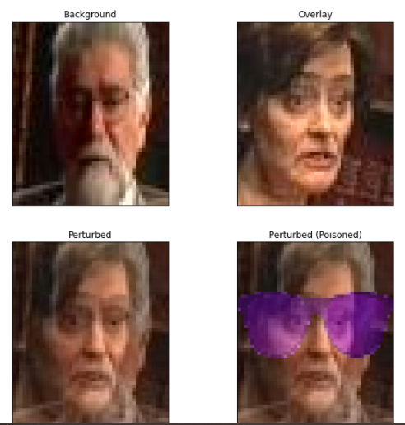

Figure 1. Clean and malicious examples after perturbation

Secondly, these perturbed inputs were fed into the BadNet and it would output N predicted results. Then we calculated the entropy to evaluate the randomness of the predicted classes of the perturbed inputs of the above original input. For the BadNet1, since we knew the malicious inputs and clean inputs, we can observe the distribution of the entropy of these two kinds of inputs. We tuned the value of N (the number of perturbed replica of an incoming input) and observe the impact on entropy distribution of clean and backdoored inputs in the following figure.

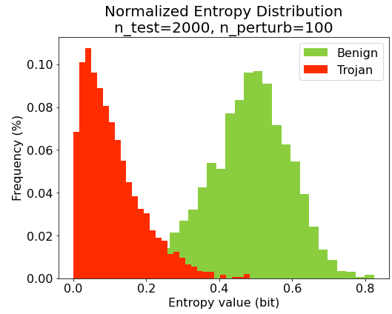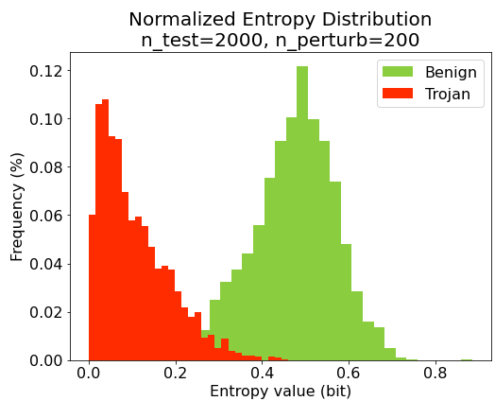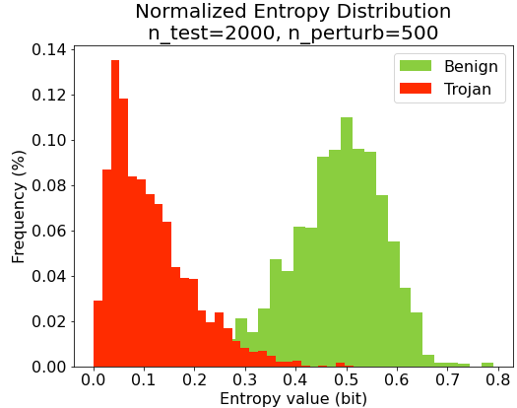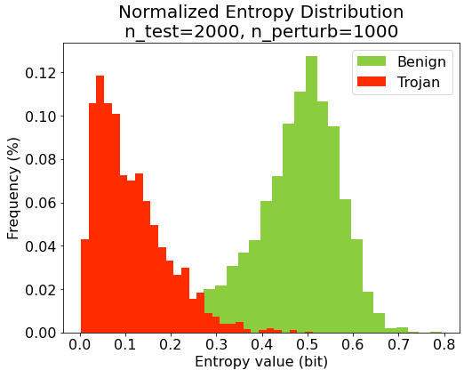

Figure 2. Entropy distribution of clean and malicious inputs

From the entropy distributions, we found given a BadNet, the backdoor tended to be triggered when the model predicted perturbed malicious input. The BadNet behaved just like what attackers expected, which generated concentrated results that had lower entropy, as we could see in the orange part. While perturbed samples of clean inputs would not trigger the backdoor and their prediction results followed a normal distribution, and the entropy values were higher than that of malicious inputs.

According to the above analysis, the next step is to decide the threshold of entropy value to separate the malicious inputs and clean inputs. Since the entropy values ​​of the two parts have a little bit of overlap and we don’t have the malicious inputs when we process the BadNet2, we cannot use the lowest value of entropy of clean inputs as the threshold. Instead, we can determine FRR at first, then calculate the percentile of the normal distribution based on the results of clean inputs. In fact, we used the percentile as the boundary to detect backdoored inputs. For the BadNet1, we tried different values of FRR to improve this trade-off between FRR and FAR. The results are represented as the following figure. Due to the space limitation of this report, table about FRR, FAR and threshold are provided in the GitHub repository.

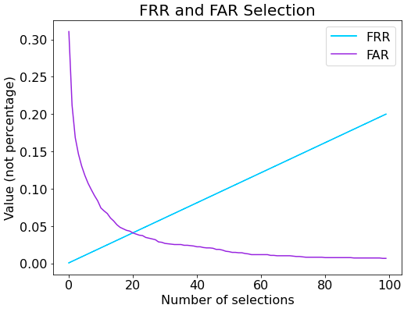

Figure 3. Value of FRR and FAR



According to the experiment data, we chose **0.2942637391590416** as the threshold.

After that, we could repair the BadNet1 and call the repaired version G1. An incoming input with the entropy results lower than the threshold would be judged as the backdoored input and the model would output class -1.

To measure the performance of G1, we used 3 validation sets:

1. 1000 samples from clean validation set and 1000 samples from poisoned data set. Label ground truth of all poisoned samples are set as -1;
2. Entire clean validation set;
3. Entire sunglasses poisoned set.

For validation set 1, we got an accuracy of 94.75%. For validation set 2, we got an accuracy of 91.64%. For validation set 3, we got an accuracy of 3.6%. The result matches what we expected: a low prediction accuracy on backdoored samples, while a high prediction accuracy on clean samples. Therefore, we can see the method STRIP works well on BadNet1 and we get a good “repaired” net.

### Repairing Anonymous Poisoned BadNet (B2)

In terms of the BadNet2, we processed the inputs in the validation datasets as the previous perturbation steps and draw the entropy distribution of the clean inputs as the figure below.

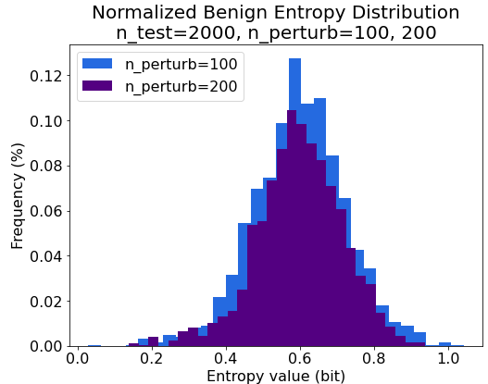

Figure 4. Normalize benign entropy distribution

Since the entropy distribution is similar to the distribution in Figure 2, and given that there is only one backdoor target output, we could expect that the entropy distribution of perturbed poisoned samples could be similar to that of sunglasses poisoned samples. This means that we may keep using the same threshold value as we obtained in the BadNet1. Still, we need to build perturbation on an incoming input when detecting backdoors, feed the input to the repaired net, calculate the entropy summation of the output, and compare the result with our detection threshold. If the result is lower than the threshold, the net will output class -1.

### Repairing Eyebrow Poisoned BadNet (B3)

For fixing eyebrow poisoned BadNet B3, what we have done is nearly the same as that in repairing Sunglasses Poisoned BadNet B1, since we were given the poisoned example along with clean example. Therefore, in this section we will focus more on the result.

Firstly, there is some significant change in normalized entropy distribution. It could be obtained that due to multiple backdoor targets, the entropy of perturbed poisoned samples has increased, which make it harder to find a proper threshold without increasing too much on FRR and FAR.

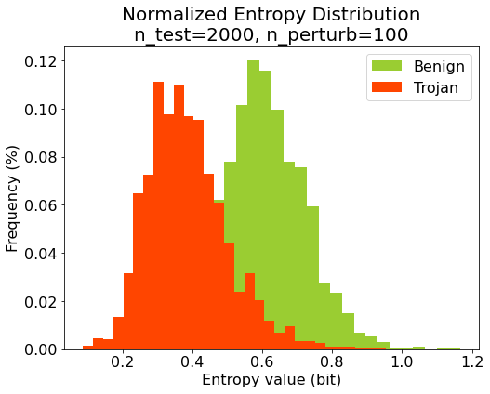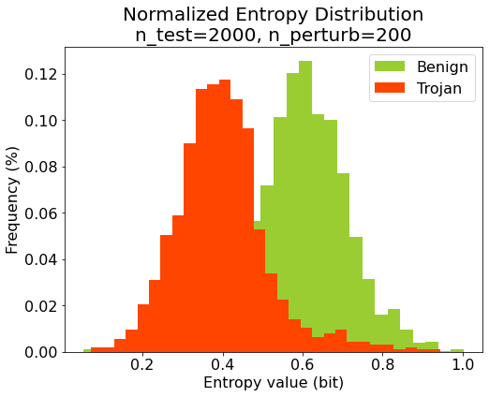

Figure 5. Normalized entropy distribution of eyebrow poisoned sample

Secondly, the FRR and FAR values are also raised. The following figure presents the FAR curve with the increase of FRR value. Through selecting the optimal threshold, the smallest FRR and FAR value we could achieve is nearly 20% each. The table of FRR, FAR and threshold is also provided in the GitHub repository.

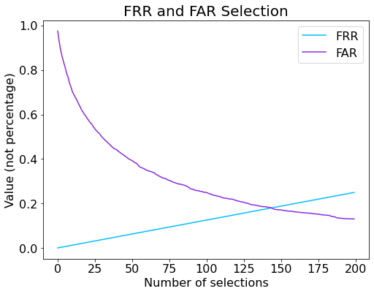

Figure 6. Value of FRR and FAR

Finally, we repaired the BadNet B3 using the selected threshold and measured the performance of repaired network G3 with 2 datasets: the clean validation set and the whole eyebrow poisoned set and. For the first dataset, we got an accuracy of 80.55%, and for the second dataset, we got an accuracy of 9.90%. These data shows that more benign samples are classified incorrectly while more trojaned samples are classified as benign samples.

### Conclusion

STRIP method for backdoored sample detection achieved satisfying performance in backdoor attacks with single target. For situation like backdoor attack with multiple triggers and multiple targets, the performance has dropped quite a lot. The possible reason is that the way STRIP distinguishes backdoored sample is based on entropy, and the entropy reveals the uncertainty. Since multiple target backdoor outputs have more uncertainty, it makes the entropy distribution of perturbed poisoned samples closer than that of perturbed clean samples.

## Reference

[1] Gao, Yansong, et al. "Strip: A defence against trojan attacks on deep neural networks." Proceedings of the 35th Annual Computer Security Applications Conference. 2019.